THE HENRY COUNTY PUBLIC LIBRARY STRATEGIC PLAN
2024 - 2026
Tony Jones, Director

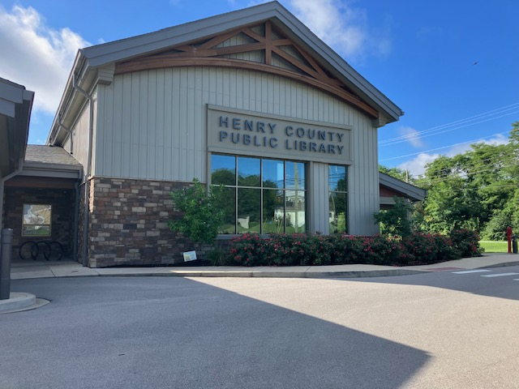

LIBRARY HISTORY
The first recorded public library service in Henry County started in October of 1954 with a bookmobile program for rural areas. Many of these first bookmobiles were donated by businessmen from Louisville and the surrounding areas and were often constructed using rebuilt army ambulances. The books were furnished by the Kentucky Library Extension Division, a state agency now known as the Kentucky Department for Libraries and Archives (KDLA). That first year, the Henry County Bookmobile stopped at the schools within the county and had an additional 18 stops in various communities. At that time, the bookmobile carried approximately 2000 titles.
In 1957 a temporary demonstration library was started in a store front in New Castle. The first Henry County Library opened in 1958 in a store front on Main Street in Eminence.
By July of 1961 the library had grown so much that it could no longer remain in its original location. That year it moved into the L & N Depot building, where it would remain until November of 1966, awaiting the construction and completion of the building on Eminence Terrace.
By November 1966 the library moved to its former location on Eminence Terrace. It was set to have an open house in April of 1967, but a cold winter froze the pipes and flooded the building in March. This postponed the open house. The library soon housed around 40,000 volumes, an excellent reference section, a growing genealogical collection, and featured an annual arts and craft exhibit.
The original building was large enough to meet the needs of the county for some time, but by 1977 the building required remodeling the existing features and the addition of a large meeting room with kitchen facilities. In 1987, work began on yet another addition to the library. An additional 3,000 square feet of much-needed space was added. This project was completed in 1988 with the help of a construction grant from the state.
In February 2020, the library moved again. It now lives at our current location, 280 East Broadway, in Eminence. The grand opening was scheduled for March of that year, but the COVID-19 pandemic heavily impacted in-person services across the globe. The library had a soft opening in 2020 and the official library grand opening took place in September of 2021. The funding source for the current location came from a KDLA building grant and serves as a community centerpiece for Henry County.
The last strategic plan was written for 2017-2019. As most libraries did in Kentucky, the strategic planning process was placed on hold for the following three years during the Covid-19 Pandemic. The upcoming strategic plan included consideration of current and emerging library trends, a study of the library’s strengths and weaknesses, and identification of library growth opportunities. Further, community input was garnered through a survey process and staff input was gained through small focus groups. In conclusion the strategic plan is written for 2024-2026 guiding the library through the next three years as they experience growth of patrons who read hundreds of volumes of literature, use the many reliable library services, and attend a myriad of excellent programs.

Our Vision:
We envision a community connected to a world of opportunity for every single citizen.
Our Mission:
We are our community’s essential source of information, ideas, and lifelong learning.
Guiding Principles:
Community: The evolution of our services is framed by community need. As we build a 21st century library, we build a 21st century community.
Innovation: We are adventurers and doers, committed to the notion that actions generate the most useful lessons.
Adaptability: We are outwardly focused, service oriented, and staffed by continuous and adaptable learners.
Accountability: Our constant pursuit of new ways to deliver services is yoked with our search for new ways to measure and communicate the impact of those services on our community.

HENRY COUNTY PUBLIC LIBRARY STRATEGIC PLAN
2024-2026
Goals and Objectives

COLLECTIONS AND CUSTOMER SERVICE
Goal I: To continue to provide a comprehensive, current, and accessible collection that satisfies varied community needs and interests.

Goal II: To provide a versatile, welcoming, and safe space that serves as the centerpiece of the community.

PROGRAMS AND SERVICES
Goal I: To continue to provide relevant and engaging programs and services that nurture and encourage literacy and learning.

Goal II: Continue programming for children that expands their minds and increases their knowledge of the world.

OUTREACH

Goal I: Continue to share library resources out into the community to promote literacy and learning activities.

Goal II: Target a location in the county that would be a repository for books and other library materials, increasing the patronage in that area and making the library more accessible.

PARTNERSHIPS

Goal I: Engage the community in developing and promoting resources and partnership opportunities.

Goal II: Assess partners and partnerships to determine if there is a need to re-establish shared outcomes and goals.

MARKETING

Goal I: Assure information on library programs and services is easily accessible to all.

Goal II: Greet and welcome new patrons with library information.

Goal III: Elevate community awareness of programs, services, and collections.

TECHNOLOGY

Goal I: Explore the possibility of adding a maker space or cart to the library offerings.

FACILITIES

Goal I: Provide a welcoming space that meets the patrons’ needs for quiet focus, community gathering, literacy and learning.

STAFF DEVELOPMENT

Goal I: Develop all staff by providing quality training and continuing education opportunities.

Strategic Plan Facilitator: Dr. Angie Taylor
Completed: December 7, 2023
Approved by the board:

